Vape Recycling Battery Pack

User Manual

Version 1.0

07/25/2023

Sam Bogonis, Matt Taylor, Aaron Lundgren

Contents

1. Introduction 3

1.1 Overview 4

2. Set-up 5

2.1 Battery Preparation 8

2.2 Battery cell installation 9

2.2 Battery Pack Connection to Main Board 11

3. User Interface 12

4. Battery Pack Usage 13

5. Additional Safety/Recycling Resources 13

6. Contributions 13

# Introduction

Inside vape devices that are constantly thrown away is a small lithium-ion battery cell that is still usable. This product platform allows you to repurpose these battery cells into a useful recycled portable battery pack. This User Manual (UM) provides the information necessary for consumers to effectively use the Recycled Vape Battery Pack kit. This kit will provide the user with all the parts to construct their own battery pack using recycled batteries harvested from disposable vape products. The UM will provide the user with the knowledge and means to harvest a vape battery as well as constructing the kit itself. It will also include how to complete the project in a safe manner, as dealing with batteries can cause bodily harm if not done properly. If this UM is followed closely and carefully, the outcome will be a power bank consisting of recycled batteries that otherwise would’ve been thrown away.

## Overview

The Recycled Battery Pack kit is equipped with inputs and outputs specific to ease of use for the product. Inputs include a 21V@1A charger that is included, with outputs being two USB-A ports capable of 5V@5A. Highly technical components are incorporated into the product to ensure functionality and safety. The ESP32 Microcontroller is the brain that hosts the web dashboard server through a locally hosted Wi-Fi network that displays information from the product to the dashboard. Three Battery Control Modules (BCM’s) are used for optimal charging and discharging of the batteries. To ensure the correct output of the product a 12V/24V to 5V DC-DC Buck Converter with an efficiency of 96% is used inside the pack. The DHT22 temperature and humidity sensor monitors the operating conditions of the battery packs. The product is equipped with an OLED display allowing for the user to see real time information about the pack including voltage readings of the individual packs as well as the entire system, the temperature and humidity readings, and the local IP address of the web dashboard. A hardware output toggle switch or “kill switch” is a safety feature included allowing the user to shut off the entire system at any point via the hardware itself rather than relying on the web dashboard interface. All components are housed in a durable casing that allows for easy use of the product. Diagrams showing how the system works are can be seen below.

As a note, always use caution when working hands-on with any electronic devices or components as mishandling of these items may cause injury to the user as well as the devices/components themselves.

# Set-up

Tools Need:

* Pliers
* Scissors (wire snips)

Removing the battery from the vape device must be done with care. Follow instructions and guidelines carefully for a successful process to ensure no issues occur. Most vape devices are the same when disassembling. The process to make sure safety is ensured is as follows.

1. Identify how the vape device comes apart. Look for a seam on either the top or bottom of the device *See figure* *2.0.* 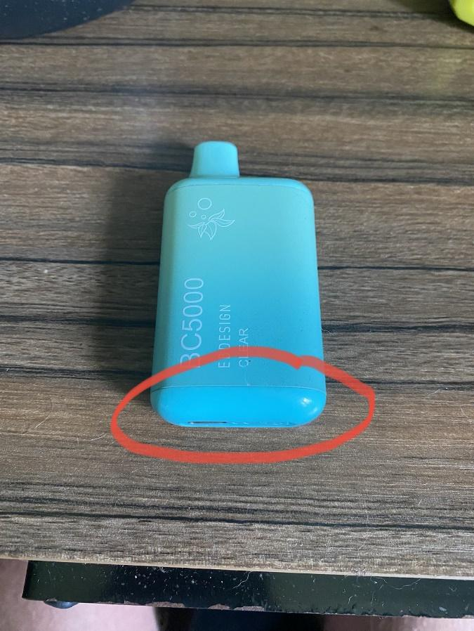

*Figure 2.0*

1. Hold on to where the device comes apart with pliers while keeping the other hand holding the other side of the device. Pull in opposite directions removing the cap of the vape. *See figure* *2.1.*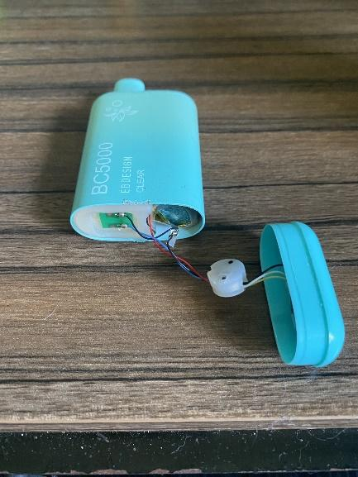

*Figure 2.1*

1. Remove the internal components from the shell of the vape device using pliers if necessary. *See figure* *2.2.*

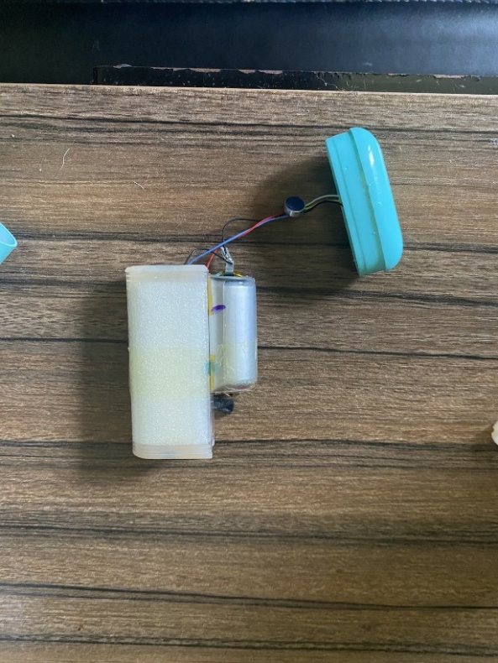

*Figure 2.2*

1. Clip each wire ONE AT A TIME connecting the battery to the vape device. Ensure the cut of the wire is as close as possible to the battery terminal. *See figure* *2.3.*

WARNING: *Both wires clipped at the same time will short the battery and can cause bodily harm.*

*Figure 2.3*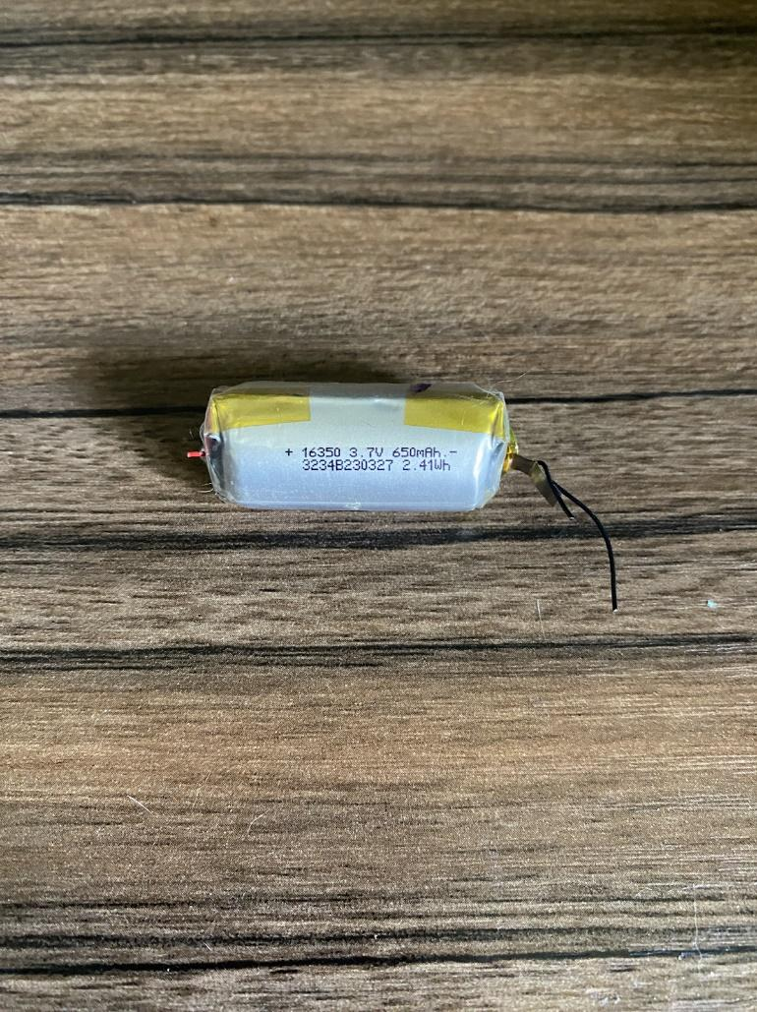

1. You have successfully removed a battery cell from the vape device.

## 2.1 Battery Preparation

WARNING: *Improper handling of lithium-ion batteries can cause bodily harm. Keep batteries at room temperature. Do not store batteries in direct sunlight or in a hot vehicle. Store batteries away from flammable materials.*

Tools required:

* Soldering Iron
* Solder
* Sandpaper

Before assembling the battery pack there are a few preparatory steps that need to take place. For each battery that is use in the device, a visual inspection of the battery terminals (the thin pieces of metal that protrude out from either side of the battery) must be conducted. Terminals that are not clean (markings, carbonization, etc) must be gently rubbed with sandpaper to remove any imperfections. If not done correctly, the solder joint may not be strong enough for safe prolonged use.

The user will need to put a bead of solder (solder ball) on the top of the contacts on either side of the battery cell for each battery. *See figure* 3.0 and 3.1. To ensure optimal battery cell health and condition, use proper soldering temperature and ensure that the time of which heat is applied to the battery is limited. Previous experience in soldering is recommended, as well as practice prior to working with battery cells. For details on proper soldering techniques, please refer to the additional safety/recyling references section.

*Figure 3.0 Figure 3.1*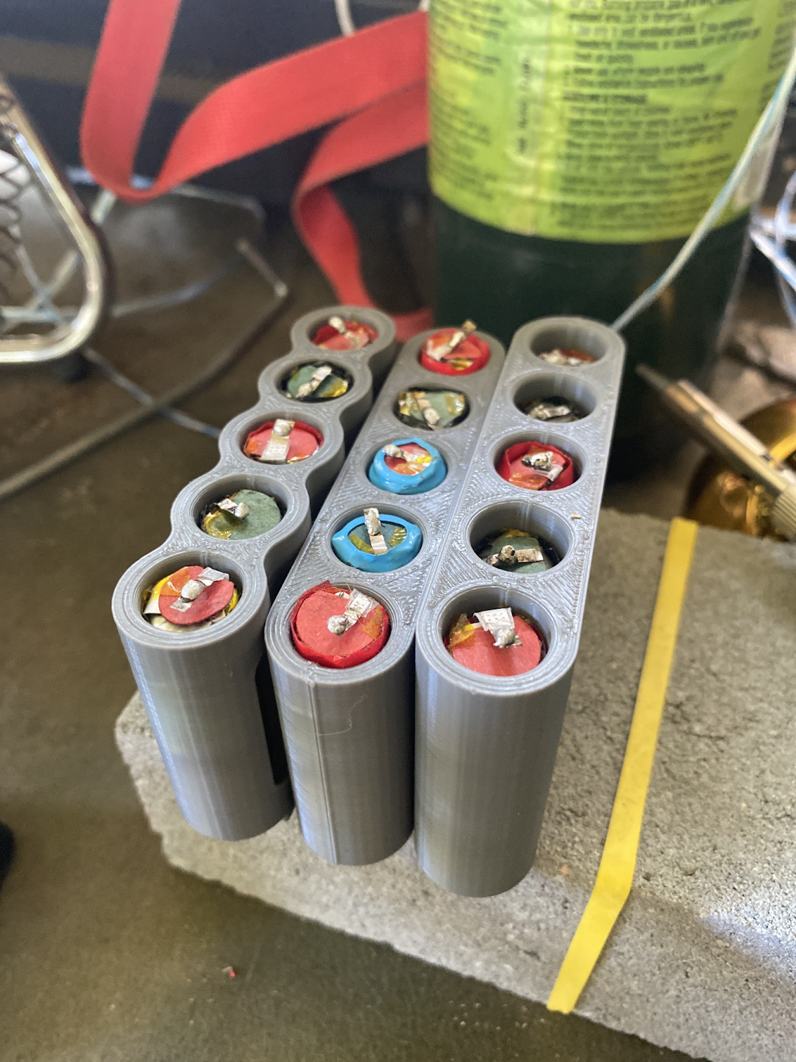

## 2.2 Battery cell installation

WARNING: *Improper handling of lithium-ion batteries can cause bodily harm. Keep batteries at room temperature. Do not store batteries in direct sunlight or in a hot vehicle. Store batteries away from flammable materials.*

Once the preliminary steps are taken to prepare each battery for use, the user will then be able to begin assembly of each pack of five cells for the battery pack. This will be done carefully and consistently with proper attention to detail. While making sure the polarity of each battery is correct (*See figure 4.1)* slide each battery into each cell holder of the pack one at a time, making sure each cell sits fully at the bottom of the holder and the newly soldered battery terminals are making proper contact with the internal nickel strips of the battery holder.

The correct polarity can be followed from left to right: POSITIVE side down, NEGATIVE side down, POSITIVE side down, NEGATIVE side down, POSITIVE side down.

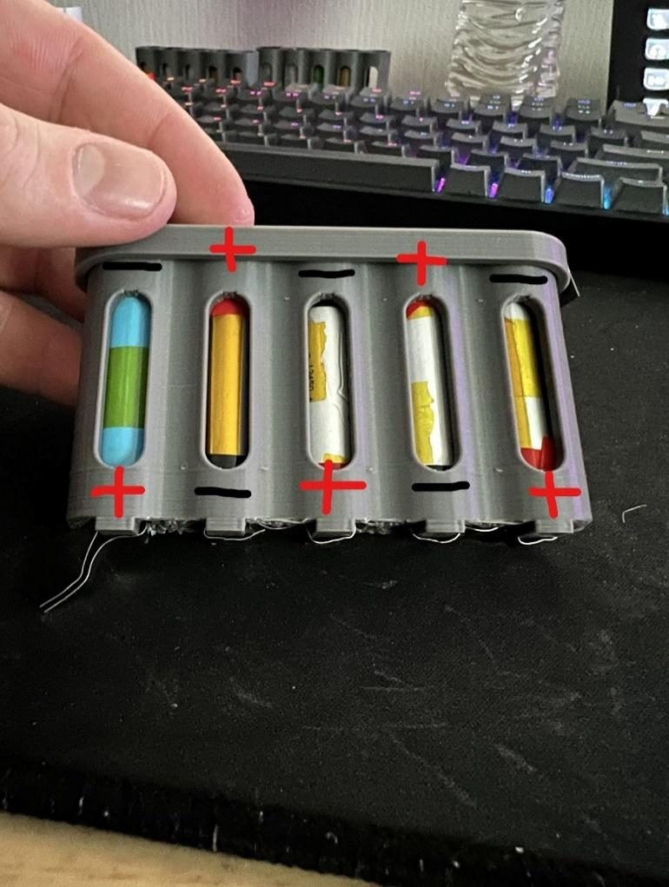

*Note: Some cells may need a gentle push to sit in each pack correctly.*

Once each cell is pushed all the way down inside the cell holder with proper orientation, the user can then press the cap onto the holder. The cap is held on by a friction fit meaning you will need to apply force to push the cap all the way on to the holder to ensure a tight fit.

## Battery Pack Connection to Main Board

After each of the three packs of five battery cells is complete, the next step is connecting each pack to the main board.

Attached to the battery pack is the Battery Control Module (BCM). Connected to the other side of the BCM is a connector that can be connected to the main board. Find the like connectors on the main board and plug each connection into the respected connector. The main board holds all the brains of the product and dictates the inputs and outputs of the device. The board is prepared with all the components needed for the functionality of the product.

# User Interface

Equipped on the product is a 0.96” OLED display (*See figure 3.0)* allowing the user to see real time information about the status of the battery pack. This information includes temperature and humidity of the pack as well as battery percentage. A more in-depth analysis and information location is the local website that is produced by the battery pack. By connecting to the Wi-Fi transmitted by the device it will update the local IP address with information on the battery pack. Total voltage of all three packs and individual voltages of each pack, humidity, and temperature are all included on the dashboard. A safety feature included in the dashboard uses the humidity and temperature readings to determine if the pack is safe or not. If the humidity sensor reads above 80% or the temperature reads above 85 degrees Fahrenheit, then the Safe output will turn to “No”.

The top set of numbers is the displayed IP address of the website.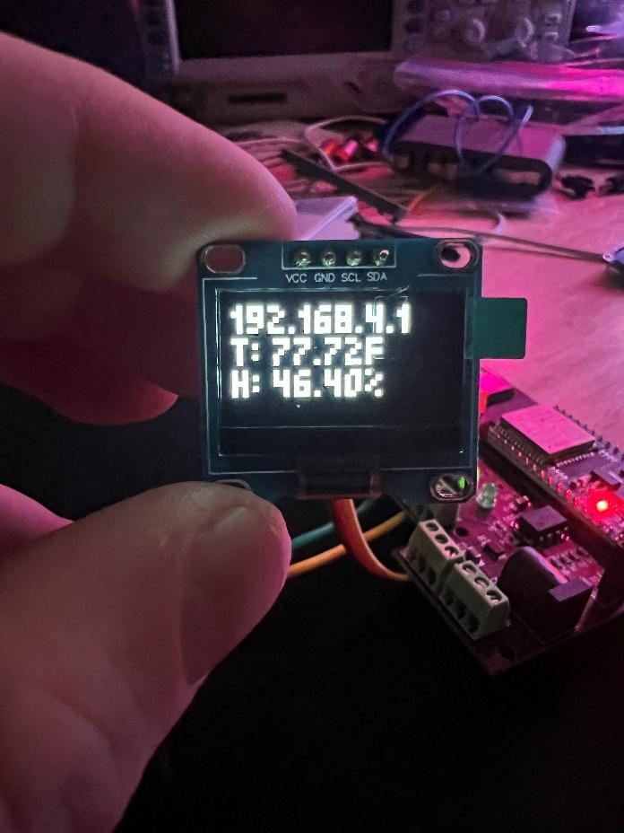

T represents temperature.

H represents humidity

*Figure 3.0*

# Web Dashboard Interface

The ESP32 Microcontroller is WiFi and bluetooth enabled, allowing the hosting of a WiFi network that can be accessed by any WiFi enabled device. When the system is on, the ESP32 will host a WiFi network that the user can connect to (most commonly via a desktop computer or smartphone). Once the user connects to the WiFi network, they can open any web browser and type in the IP address of the device that is displayed on the OLED display (Typically, the IP address defaults to 192.168.1.4). At this time, the user will be greeted with the Vape Battery Pack Dashboard. This dashboard displays important information about the device, including voltage readings from each of the three battery packs, the total voltage of all of the packs combined, the charge percentage of the device, the temperature and humidity readings, and an output toggle button to control the output power of the two USB-A connectors (See Figure 4.1).

*Figure 4.1*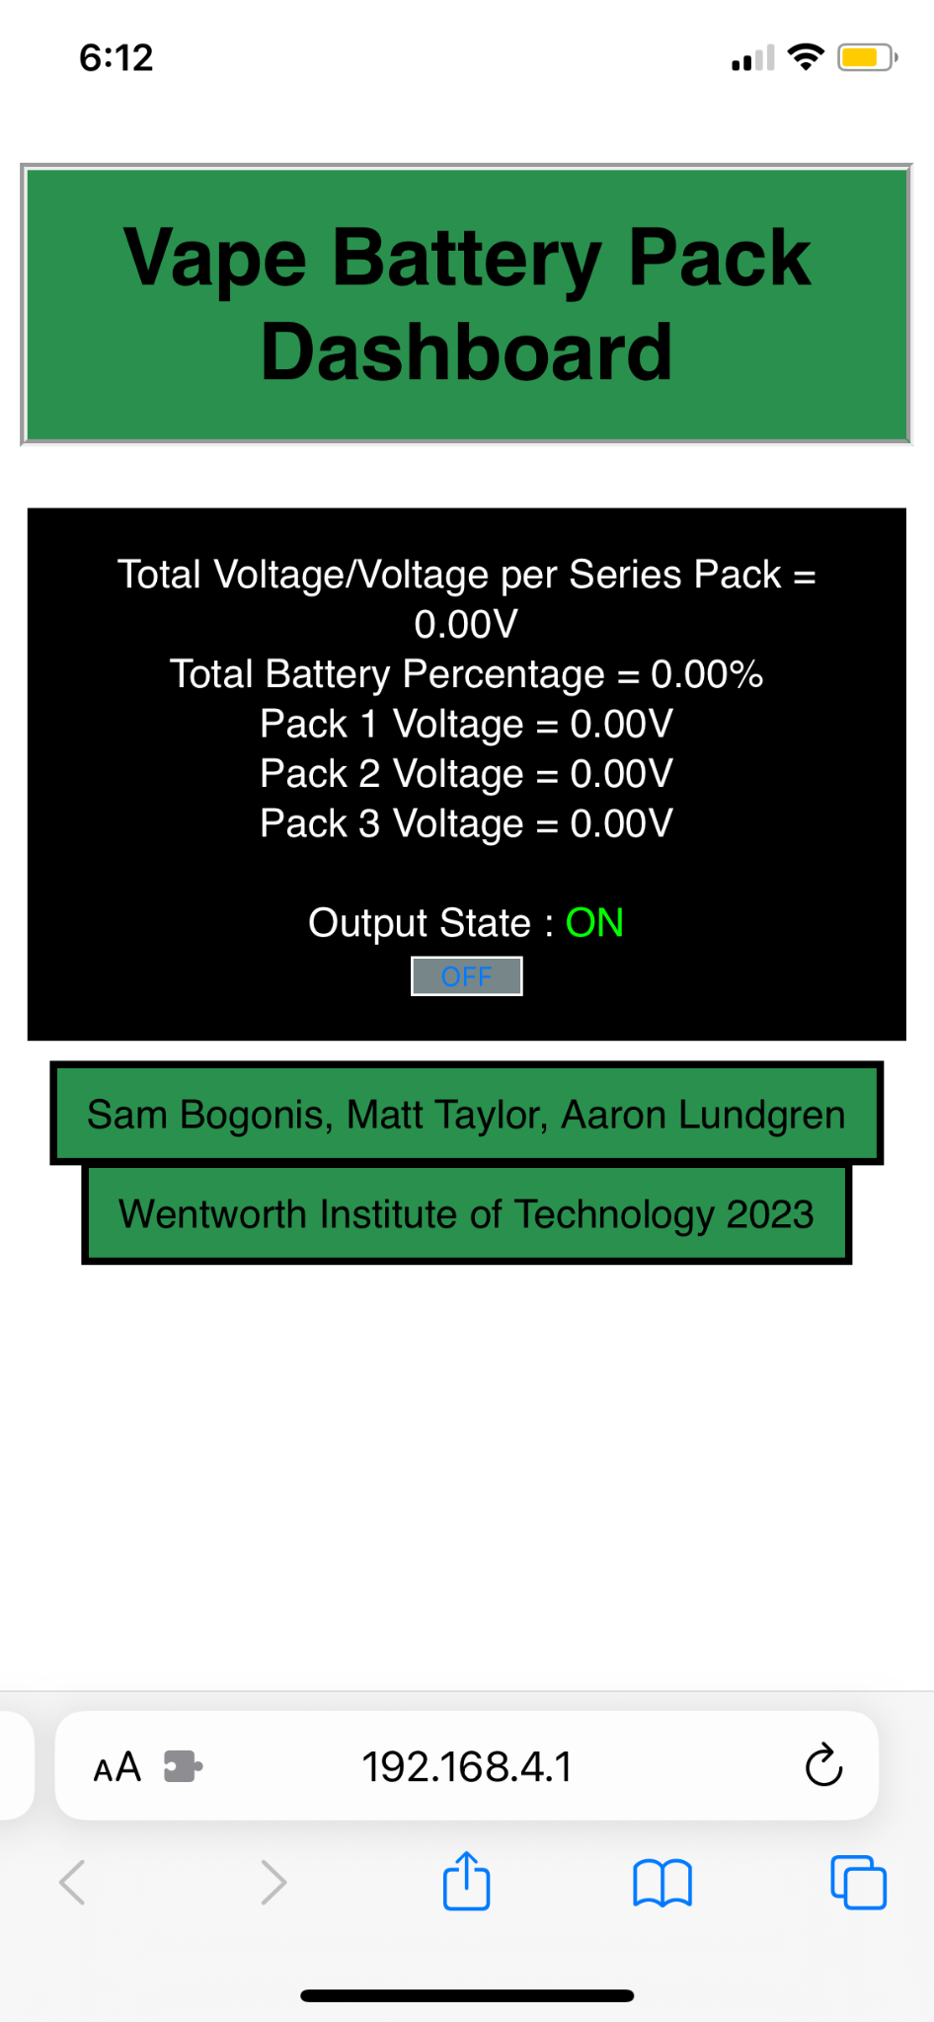

# Battery Pack Usage

Once all separate battery packs are placed inside the case and connected properly the battery pack is ready to be used. The battery pack is turned on with a switch and the outputs are provided with power. Each of the two USB-A output is provided with 5V and a combined current rating of 5A. The battery pack is charged with the provided 21V@1A charger.

# Additional Safety/Recycling Resources

**Safety Resources include but are not limited to:**

<https://www.osha.gov/sites/default/files/publications/shib011819.pdf>

**Recycling Resources include but are not limited to:**

Home Depot Offers Battery drop off locations for recycling.

<https://www.epa.gov/recycle/used-lithium-ion-batteries>

**Skill Building Resources (Soldering) include but are not limited to:**

*GreatScott!:* How to Solder properly || Through-hole (THT) & Surface-mount (SMD)

<https://www.youtube.com/watch?v=VxMV6wGS3NY&pp=ygUVc29sZGVyaW5nIGdyZWF0IHNjb3R0>

**Knowledge Building Resources include but are not limited to:**

*Lesics*: Lithium-ion battery, How does it work?

<https://www.youtube.com/watch?v=VxMM4g2Sk8U&pp=ygUcbGl0aGl1bSBpb24gYmF0dGVyeSB0dXRvcmlhbA%3D%3D>

GreatScott!: How dangerous are LiPo batteries? || Overcharge, Overdischarge, Short Circuit

https://www.youtube.com/watch?v=osfgkFyq7lA&pp=ygUoZ3JlYXQgc2NvdHQgbGl0aGl1bSBpb24gYmF0dGVyeSB0dXRvcmlhbA%3D%3D

*GreatScott!*: Li-Ion battery short circuit, overcharge, undervoltage EXPERIMENT

<https://www.youtube.com/watch?v=bNNWbm681AI&pp=ygVBTGktSW9uIGJhdHRlcnkgc2hvcnQgY2lyY3VpdCwgb3ZlcmNoYXJnZSwgdW5kZXJ2b2x0YWdlIEVYUEVSSU1FTlQ%3D>

bigclivedotcom: Scavenging rechargeable lithium cells from the roadside

<https://www.youtube.com/watch?v=N65DpT2nqEI&pp=ygUbYmlnY2xpdmVkb3Rjb20gdmFwZSBiYXR0ZXJ5>

bigclivedotcom: inside a disposable with charging port

https://www.youtube.com/watch?v=hBgaqY9CG3g&pp=ygUbYmlnY2xpdmVkb3Rjb20gdmFwZSBiYXR0ZXJ5

Many additional resources are available across the internet. For further information regarding electrical concepts, lithium-ion batteries, safety practices and procedures, and more in depth circuit analysis please visit the some of the following resources:

bigclivedotcom, GreatScott!, ElectroBOOM, Louis Rossman, LTT, EEVblog, HACKADAY, Phil’s Lab

Adafruit Industries, SparkFun Electronics

# Recognitions

Wentworth Institute of Technology

Prof. Saurav Basnet